**Trending Effects Report**

My first assumption from a naive perspective one would assume that the trending of unnatural deaths should match the trending of population growth. I.e. the death rates should directly tie into the population growth rate. Please note all graphs have Total (blue), Male(orange) and female(green).

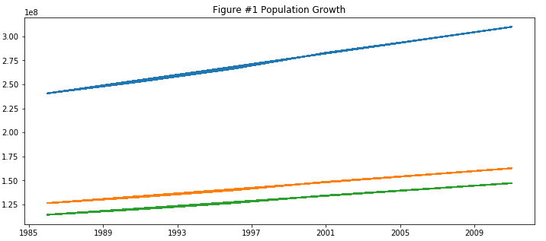

There are so many other factors that come into play when we are looking at the death rates . Geo-political, environmental, Economical, etc. With the data we believe one will be able to tie any anomalies in the growth. Taking the total death trending as an international total one can see the trending is more erratic than the population trending.

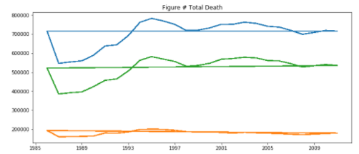

When splitting the unnatural deaths by type :

*Transportation incidents when taken as an aggregate has an overall downward slope showing that even though the population is trending upwards. This is contrary to our initial suggestion of naive correlation.*

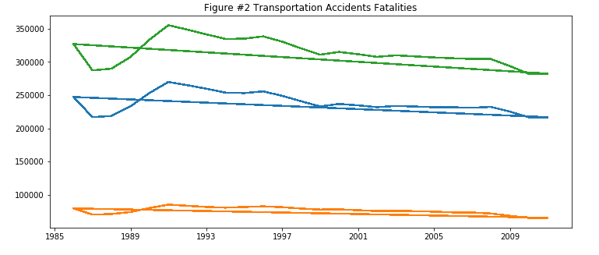

*Incidents involving falls have an upwards slope but have more volatility than that of the population growth.*

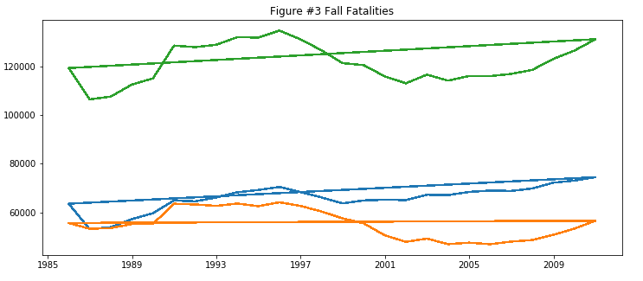

*Drowning Fatalities are on a decline as well, which is contrary to the population growth.*

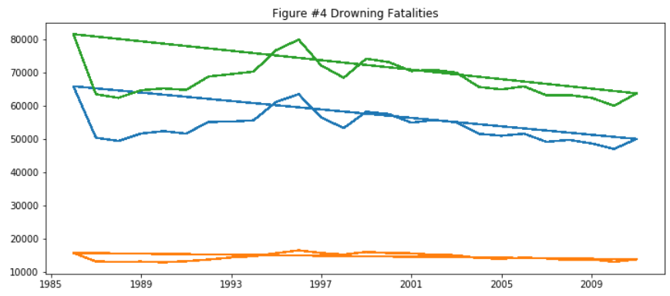

*Assault Incidents follow a similar population growth. This shows more of a correlated relationship with Assaults and Population.*

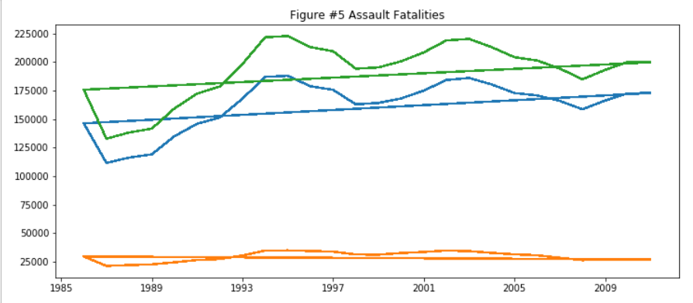

*The final 3 types of death are all on the decline, Suicide, Transportation accidents and Fire incidents.*

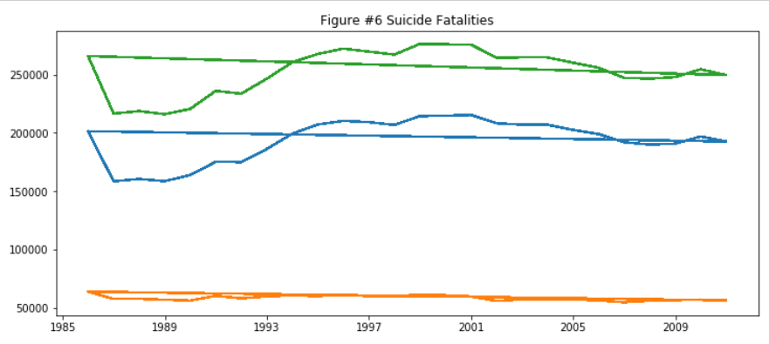

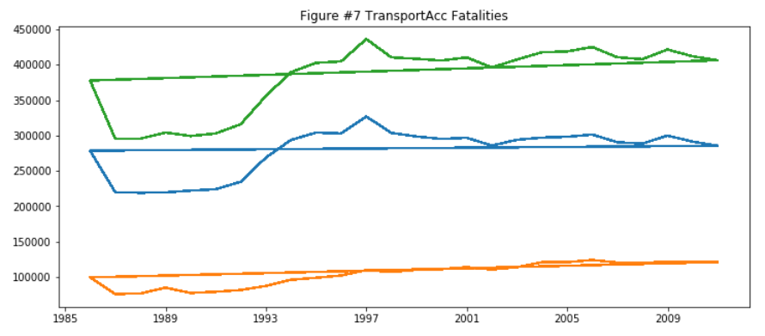

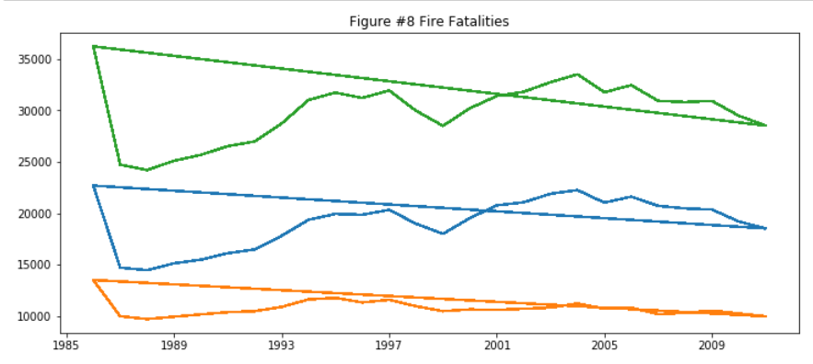

By differentiating the types of deaths one can see that not all deaths are equivalent. They all seem to be trending independently from both the population growth and from one another. Let’s dig in further into the data we have available to see what insights we can pull from the data. We will dig into the classified deaths by country, the top 5 as we have about 100 datapoints on country.

There are 2 key countries currently missing from the dataset China and India. There are no records on unnatural deaths. There was a lot of information on natural deaths but that is not our focus.

In my analysis will define the top 5 by the magnitude of the sum of all death types. The assumption is that there will larger factors (cultural, geopolitical , disasters.etc.) that will be more evident that smaller counts that may have larger percent against population.

**Transportation Incidents**

The international Transportation incidents appear to be on the decline (figure #2) but is this true for all nations. The top 5 countries by incident count are United States, Russia, Brazil , Japan and Mexico.

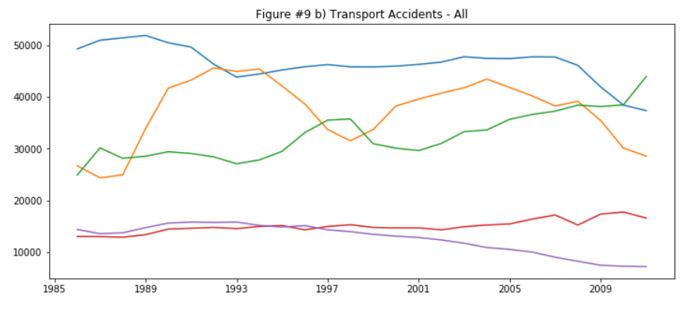

All appear to be on the decline except for Brazil. Brazil’s appears to remain flat and after 2009 starts to increase. I’ve decided to focus on this unique trending. There has to be a story behind it.

Taking a look at the automotive sales trending in Brazil they trend almost exactly the same as the Transportation incidents. The increase in vehicle sales is related directly with Brazil’s GDP growth. I read an anecdotal comment in an article about Brazil stating that the automobile is a symbol of status.

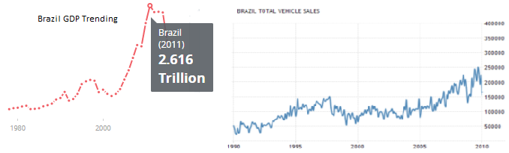

Source of Graphs: <https://tradingeconomics.com/brazil/total-vehicle-sales> & <https://data.worldbank.org/country/brazil>

**Death By Assault**

Assault incidents overall are trending upwards overall. When we look at the top 5 countries by murder counts are Brazil, Russia, Colombia, United states and Mexico.

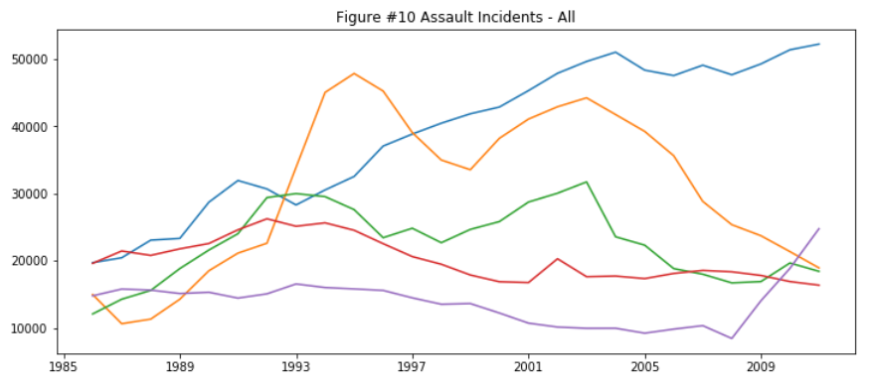

Brazil and the United States are both on the rise while Colombia and Mexico are trending flat and Russia’s murder rates are on the decline. I’d like to focus on Brazil and the United states.

Brazil currently ranked as number one by shear numbers. In 2015 there were more murders in Brazil than the rest of the developed world combined. Here is a Treemap of this statistic:

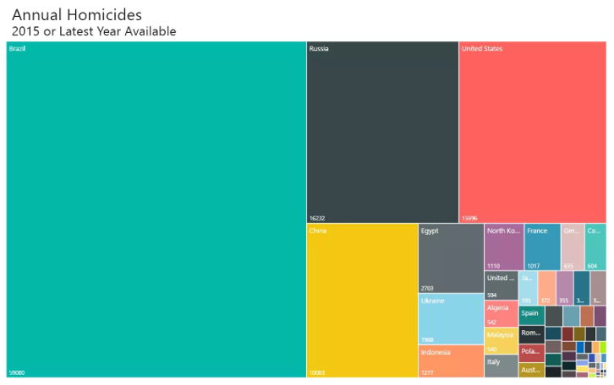

Graph source:<http://metrocosm.com/homicides-brazil-vs-world/>

I’ve found several articles attributing the causes to several different factors, drugs, gangs, the displeasure with government abuse.

Looking into the United States I found the statistics on the murders in the 2016.

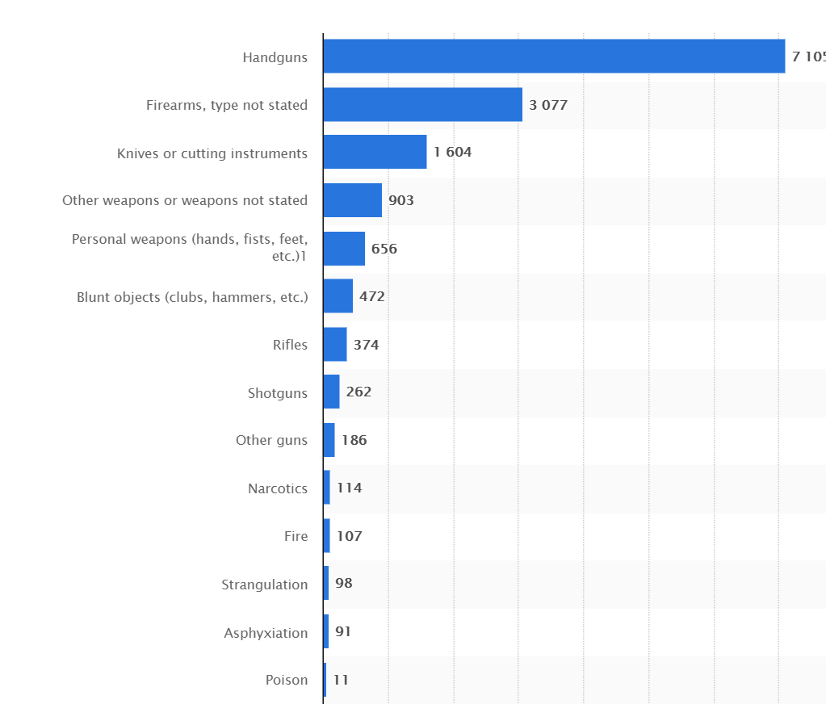

Graph Source: <https://www.statista.com/statistics/195325/murder-victims-in-the-us-by-weapon-used/>

Majority of the 2016 murders were caused by some sort of firearm. It’s not a clear correlation but I found the trend of gun sales in the United states going back to 1994. One can see there’s a spike in 2009, which corresponds to the world health organizations spike in murder rates in the U.S. also in 2009.

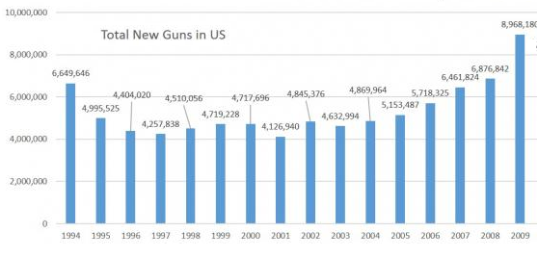

Graph source: <https://www.statista.com/statistics/249740/percentage-of-households-in-the-united-states-owning-a-firearm/>